Agent Classification

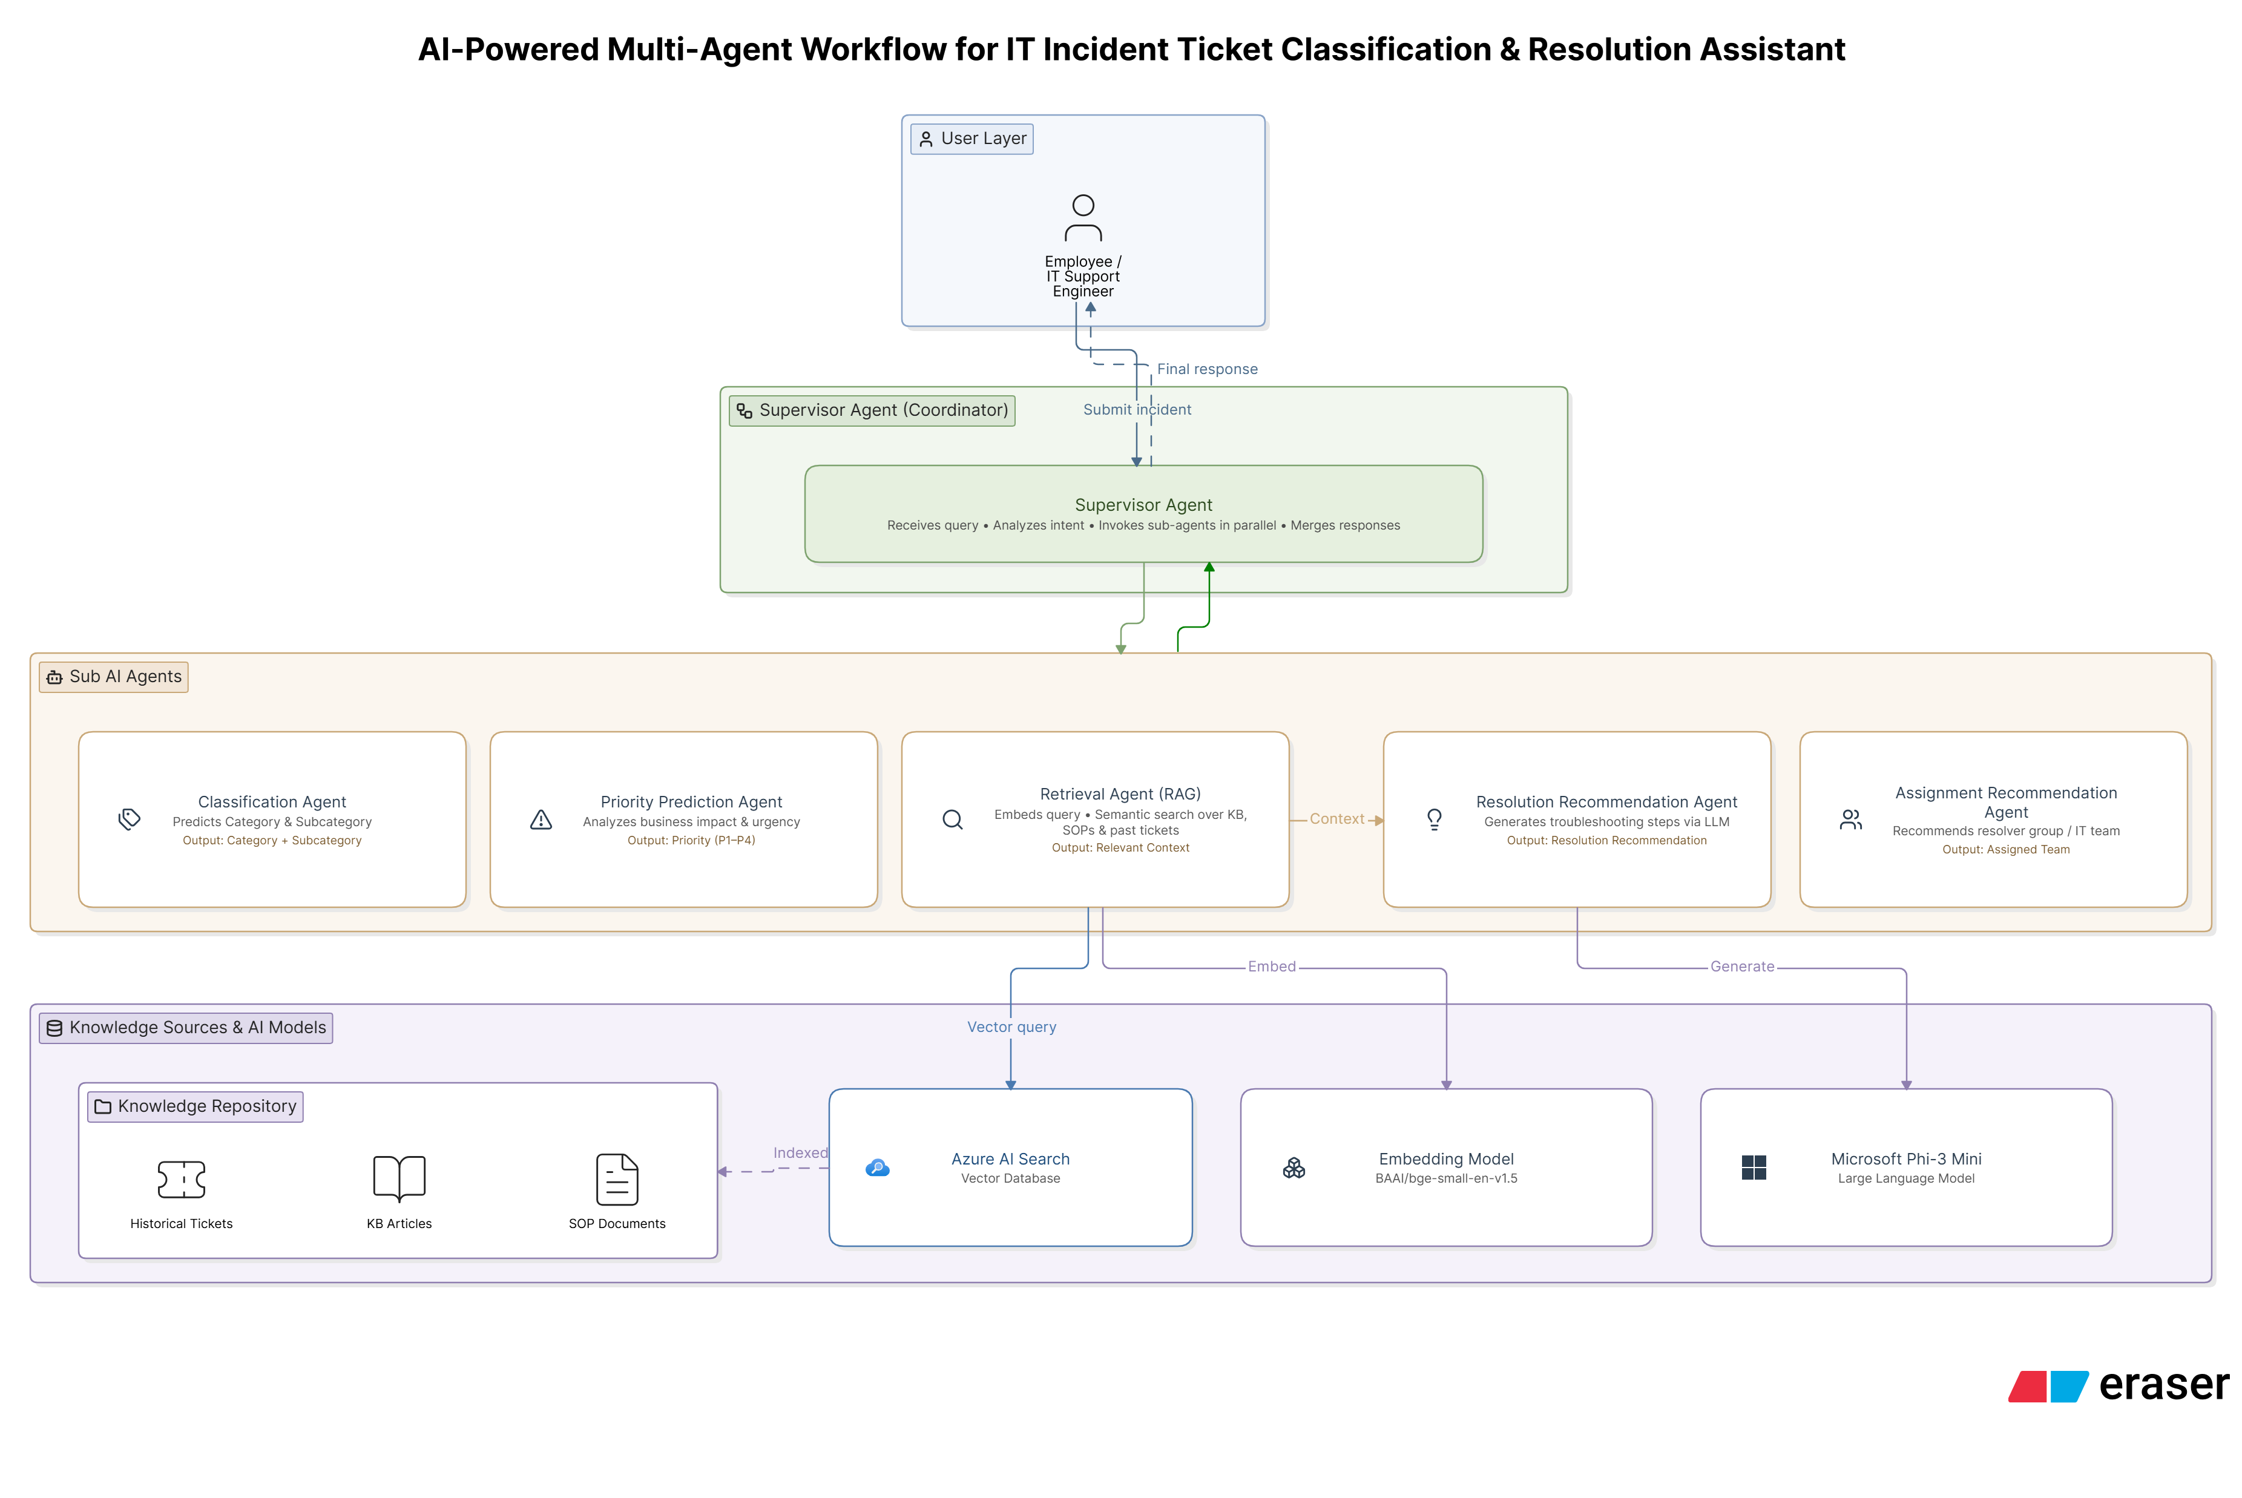

Agent | Activities Performed
Supervisor Agent (Coordinator) | Receives the user query, identifies the required tasks, invokes the specialized agents in parallel, collects their outputs, merges the results, and returns a single final response.
Classification Agent | Analyzes the incident description, predicts the ticket category and subcategory, and provides a confidence score.
Priority Prediction Agent | Evaluates the incident's impact and urgency to assign a priority level (P1–P4).
Retrieval Agent (RAG) | Converts the query into embeddings, performs semantic search in Azure AI Search, retrieves similar historical tickets, knowledge base articles, and SOPs, and provides relevant context to the Resolution Agent.
Resolution Recommendation Agent | Uses the retrieved context and Microsoft Phi-3 Mini to generate troubleshooting steps and recommend the most appropriate resolution.
Assignment Recommendation Agent | Analyzes the classified ticket and recommends the appropriate IT support team or resolver group for handling the incident.

